Development Specifications Document (DSD)

*Process Name:* *TopBoxOfficeMovies*

Table of Contents

**Document Overview**1

Automated Master Project Details 1

Runtime Guide 2

Runtime Diagram 2

List of Packages 2

Master Project Runtime Details 3

**Project Details**4

Project Name: TopBoxOfficeMovies  5

Workflow(s) specific to the Project 6

**Compliance Considerations and Reporting Requirements**8

**Other Details**8

Future Improvements 8

Debugging Tips 8

Other Remarks 8

**Post UAT Specifications**9

**Glossary**9

Version Control

|  |  |  |  |  |  |  |
| --- | --- | --- | --- | --- | --- | --- |
| Date | Version | Role | Name | Organization Department | Function | Comments |
| 20-09-2021 | 1.0 | Author | Sherif Radwan | N/A | N/A | N/A |



# Document Overview

The Development Specifications Document (DSD) is created for every business process automated using RPA. The DSD needs to be reviewed and updated for every change requested and applied to the automated process. This document provides a technical snapshot and must always reflect the latest design and key features of the automated workflow.

The document naming convention will follow the naming convention and the version of the automated process. This can be “business process name version” or it can be defined, case by case, as part of the larger RPA project design.

This document is completed by the RPA Solution architect and RPA developer who automates the business process. It is reviewed by the business process owner, application owner, and CoE design authority.

This document is meant to assist the RPA COE, IT operations and process owners by providing a snapshot of the automated process details and components. It can also serve developers to have a quick glance at the setup, before diving into the code, to troubleshoot or update changes. The purpose of the document is to record the outcome specific to the automated master project and its subcomponents: projects, workflows, sequences etc.

# Automated Master Project Details

Details filled in by the developer reflect the actual information for the master project released for production.

|  |  |  |
| --- | --- | --- |
| # | Item | Details  Fill in with free text. If not applicable, mark the filed as "N/A". No empty fields. |
| 1 | Master Project Name and Version | TopBoxOfficeMovies |
| 2 | Robot Type (attended/unattended/mix) | Attended |
| 3 | Is Orchestrator used? (Yes/No) | Yes |
| 4 | Scalable? (Yes/No)  Can the process be run by multiple robots in parallel? | No |

# Runtime Guide

## Runtime Diagram

**Architectural Structure of the Master Project** Display the interaction between components (package / robots, Orchestrator queues, and running order).

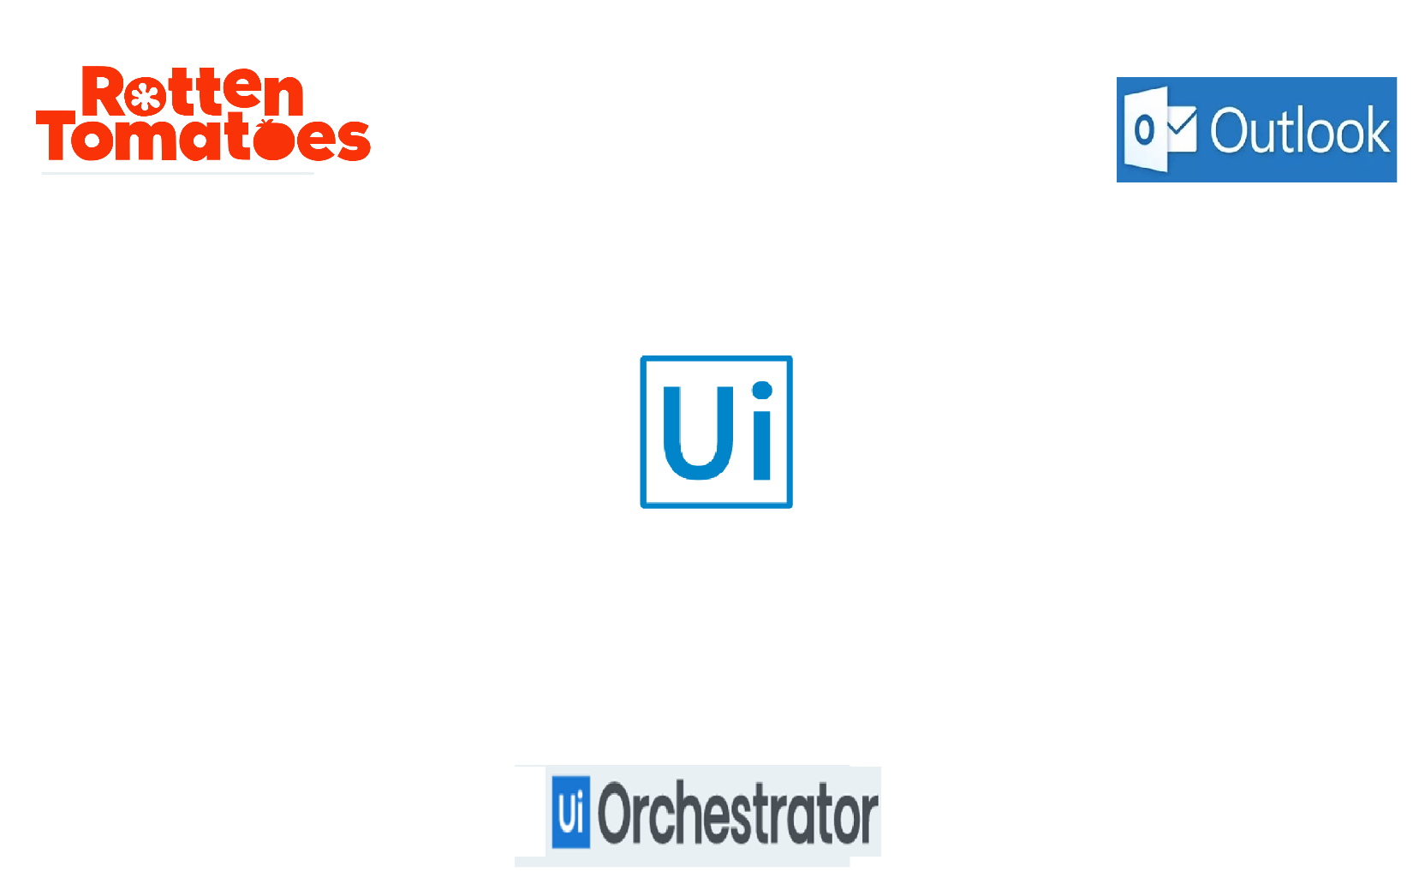

Send an excel sheet with the info of the top 10 movies.

Get the names and links of the top 10 box office movies and their info.

Bot takes URL and mail addresses from the Assets.

Bot uploads the movies, info to the queue.

## List of Packages

Include **the list of packages and the high level description** for each of them, to explain each one's purpose:

|  |  |  |
| --- | --- | --- |
| # | Package Name | High-Level Description |
| 1 | TopBoxOfficeMovies | Email a list of mail addresses, with an excel sheet that contains the top 10 box office movies and their available information from “Rotten Tomatoes” website. |

*Add more rows to the table to include all the project names and versions. No fields should be left empty. Use “N/A” for the items that don't apply to your project.

## Master Project Runtime Details

Details of the automated process:

|  |  |  |
| --- | --- | --- |
| # | Item | Details  (Fill in with free text. If the section does not apply to your automation, mark the field as “N/A”. No empty fields. ) |
| 1 | Production Environment Details | Personal machine: “desktop-qnpgh8k\hp” |
| 2 | Prerequisites to run | Microsoft Edge is installed, and UiPath Extension for it is installed,  Microsoft Excel is installed,  Microsoft Outlook is installed and “Sheko4RPA” account is signed in. |
| 3 | Input Data | Top 10 box office movies, and their info from “Rotten Tomatoes” website. |
| 4 | Expected Output (output data) | Excel sheet, that contains the information of the top 10 box office movies; And the sheet is sent to the required mail addresses. |
| 5 | How to start the automated process? | Scheduled to run automatically every Monday at 8:00 AM. |
| 6 | Resuming the process from a particular step | N/A |
| 7 | Reporting  queues reporting, Kibana or another platform | Using Logging. |
| 8 | Manual Error Handling  roll back or manually complete failed transactions. Procedures to reset the item. Ex “set status as investigating” | N/A |
| 1. How to resume the process in case of error | N/A |
| 1. How to manually fix transactions with error | N/A |
| 9 | Use of Orchestrator | Yes |
| 1. Password Policies   specific compliance requests? | N/A |
| 1. Stored Credentials   Never hard code credentials in the workflow | N/A |
| 1. List of Asset Names | * RottenTomatoesBoxOfficeURL * RT_MailAdresses * ExceptionsMailAddress |
| 1. List of Queues Name | * RT_TopBoxOffice |
| 1. Schedule Details | Weekly, on Monday at 8:00 am (UTC). |
| 10 | Recommended Resolution | N/A |

# Project Details

In this section describe all the projects that compose the automated process.

For each project, describe the workflow(s) in the logical order that they are called in.

If the workflow is a flowchart, also include the exported image from Studio.

If the automated process is composed of multiple projects, copy paste and fill in the table below for each project with its specific details (there are 2 here already, assuming a dispatcher and performer project)

## Project Name: TopBoxOfficeMovies

General information about the process selected for RPA prior to automation.

|  |  |  |
| --- | --- | --- |
| # | Item Name | Details  Fill in with free text. If not applicable, mark the field as “N/A". No empty fields. |
| 1 | Environment used for development  name, location, configuration details etc | Windows 10, Local machine.  Machine Name “desktop-qnpgh8k\hp”. |
| 2 | Environment prerequisites  OS details, libraries, required apps | OS: windows 10.  Microsoft Edge is installed, and UiPath Extension for it is installed,  Microsoft Excel is installed,  Microsoft Outlook is installed and “Sheko4RPA” account is signed in. |
| 3 | Logging level | Info, Trace, Worn, Error, Fatel. |
| 4 | Details about automation  if the apps were automated using UI Automation, Image & Text | UI Automation. |
| 5 | In case of attended bot, can the user operate the computer while the robot is running? | N/A |
| 6 | Repository for project  where the developed project is stored | Local machine “E:\Projects\RPA\UiPath\UdacityNanodegree_Projects\Udacity_TopBoxOfficeMovies”. |
| 7 | List of reused components | N/A |
| 8 | Custom logs defined in the workflows  where Throw Activity was used or custom log message was defined | N/A |
| 9 | Frequent errors found in the development phase | * The box office page URL is incorrect. |
| 10 | Workarounds used in the automation phase | N/A |
| 11 | Configuration method  assets, excel file, Json file | N/A |
| 12 | Configuration details  path for input files, configuration Orchestrator assets used | Orchestrator assets used:  - RottenTomatoesBoxOfficeURL  - RT_MailAdresses  - ExceptionsMailAddress |
| 13 | Workflow File Export List  Use the project mapping tool | N/A |

### Workflow(s) specific to the Project

Define below all the workflow files (.xaml files) used in the project, with the Input and Output data.

|  |  |  |  |  |
| --- | --- | --- | --- | --- |
| # | Workflow File Name | Description | Arguments | Comments |
| 1 | KillAllProcesses | Force the termination of the Windows processes representing applications used in the process being automated. | i/p:  in_ProcessesNamesArr : string  o/p:  N/A | N/A |
| 2 | TakeScreenshot | Capture a screenshot, log its name and location and save it with the PNG extension. If no specific filepath is passed as argument, it saves the image in the folder specified by in_Folder. | i/p:  io_FilePath : string  in_Folder : string  o/p:  io_FilePath : string | N/A |
| 3 | RottenTomatoes_GetTop10Movies | Get rotten tomatoes box office page from orch assets, then open it on edge and scrap the top 10 movies in the list. | i/p:  in_OrchFolder : String  o/p:  out_Top10MoviesDT : DataTable | If Rotten tomatoes did not open -which means that the URL is incorrect- end the process. |
| 4 | Orchestrator_PopulateQueue | Populate the orch queue with the top 10 box office movies.  Each item should have (Name, URL) and the reference is  “MovieName_ddmmyyyy”. | i/p:  in_Top10MoviesDT : DataTable  in_QueueName : String  in_OrchFolder : String  o/p:  N/A | N/A |
| 5 | Orchestrator_ProcessTransactions | Process the transactions in the orch queue, invoke the required workflows, and set the status of the transactions afterwards. | i/p:  in_QueueName : String  in_OrchFolder : String  in_OutlookAccount : String  o/p:  out_Top10MoviesDT : DataTable | N/A |
| 6 | RottenTomatoes_GetMovieInfo | Navigate to the passed movie URL, then extract the required info and add it to the io_Top10MoviesDT Datatable output argument. | i/p:  io_Top10MoviesDT : DataTable  in_MovieURL : String  in_MovieName : String  o/p:  io_Top10MoviesDT : DataTable | Some of the movie’s info may be missing from the moiveInfo section in the movie’s page, if so, set the value of the corresponding info to “N/A”. |
| 7 | Excel_SaveMoviesInfo | Save the passed in_Top10MoviesDT in an excel file.  The file name is “Top 10 Box Office Movies - ddMMyyyy.xlsx”, and the sheet name is “Rotten Tomatoes”. | i/p:  in_Top10MoviesDT : DataTable  o/p:  out_MoviesFilePath : String | The file should be saved under the “Data\Output” folder in the project directory. |
| 8 | Outlook_SendMoviesUpdate | Get the required mail addresses from the orch assets, and send to them, the movies excel file, with the required subject and body. | i/p:  in_MoviesFilePath : String  in_OutlookAccount : String  in_OrchFolder : String  o/p:  N/A | The subject of the mail is  “Top 10 Box Office Movies | dd/MM/yyyy Update”  And the body is  “Hi,  Find attached the top 10 box office movies on “Rotten Tomatoes”.  Regards,  Ui Bot”. |

# Compliance Considerations and Reporting Requirements

* N/A

# Other Details

## Future Improvements

* Filter the movies in the list based on the regions the users are in.

## Debugging Tips

* Make sure that the outlook account, the orchestrator queue and assets, are as provided in the document.

## Other Remarks

* N/A

# Post UAT Specifications

* Average duration per transaction (varies depending on the Test environment): 20 sec.
* Recommended number of robots for the specified volumes: one.
* Specified schedule: weekly on Monday at 8:00 am.

# Glossary

* **Master project** - the overall output of the development, containing one or multiple projects that together cover the scope of the robotic process automation.
* **Project** - a UiPath Studio project containing one or multiple workflow files. A project can be converted to a package and run independently, covering a particular scope within the master project. The project is used when defining the development and support phase of the automation.
* **Package** - the output of compiling a project. A package can be deployed on the robot machine and be executed by the robot service. Only one package can be executed at a given time by a robot. The package is used when defining the running phase of the automation
* **Workflow** - a component of the package, the workflow encapsulates a part of the project logic. The workflow can be of type: sequence, flowchart or state machine. a workflow is saved as an .xaml file inside the project folder. A workflow file can be invoked from another workflow and by default there is an initial workflow file that will run when executing the package.
* **Activity** - an action that the robot executes.
* **Sequence** - a workflow where activities are executed one after another, in a sequential order
* **Flowchart** - a workflow where activities are connected by arrows and the logic of the workflow can be easily followed in a visual manner. The flowchart can also be exported as an image from UiPath studio
* **State machine** - a more advanced way of organizing a workflow, similar to a flowchart.
* **BOR** - Back office robot
* **FOR** – Front office robot
* **Orchestrator** – Enterprise architecture server platform supporting: release management, centralized logging, reporting, auditing and monitoring tools, remote control, centralized scheduling, queue/robot workload management, assets management.